W1MJ 5-Watt Fox V1.0

Eliot Mayer W1MJ
January 15, 2022
Updated September 22, 2023

Contents
Introduction 1
Main Diagram 3
Top-Level Bill of Material 4
Temperature Considerations 4
Antenna 5
Design, Interface Circuit 6
Assembly, MP3 Player & Interface Circuit 9
Test Results 10
Bench Measurements 11
Final Assembly Tests 12
Antenna Measurements 12
MP3 Scripts 12
Appendix 1: UV-5R Interfacing Information 16
Appendix 2: MP3 Player Information 18
Description from Amazon 18
MP3 Player Measurements & Observations 19

Introduction

This document describes the design of the W1MJ 5-Watt Fox, Version 1.0. This type of fox is an automated radio transmitter used by the amateur radio community in hidden transmitter hunts, AKA fox hunts.

This fox uses an mp3 player to send voice messages to a Baofeng UV-5R handheld transceiver via a homebrew interface.

The UV-5R has a VOX feature, but it exhibited undesired dropouts even at maximum sensitivity. The dropouts could be eliminated by adding a strong “sub-audible” tone to the recording. However, the interface in this design contains its own VOX circuit, which controls the radio’s PTT (transmit control) input. The sub-audible tone is therefore not needed.

This fox has been re-designed with new features. See http://www.w1mj.com/fox.

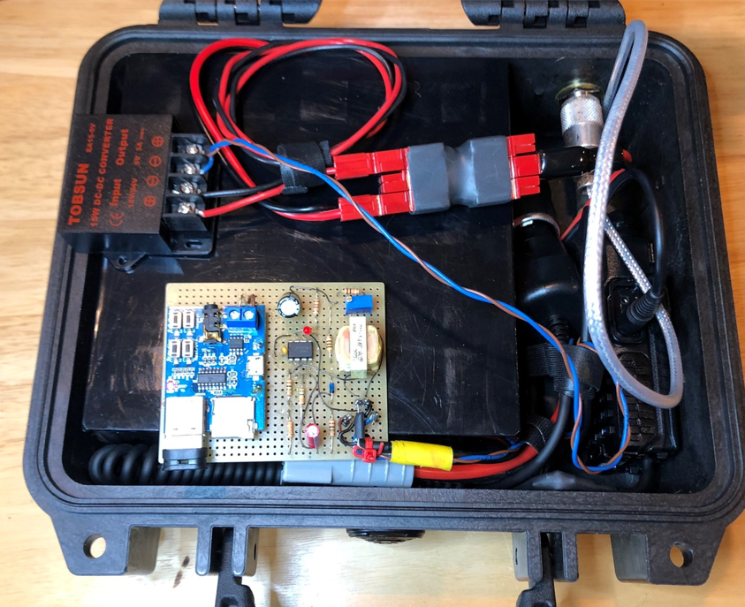
Radio
Battery
Interface
MP3 Player

Main Diagram

Cigarette lighter plug contains voltage regulator
3.5 mm jack
Audio & PTT
SMA-UHF
Adapter
Radio
Antenna
UHF
Barrel
Case
5VDC
5V (-) internally connected to Input (-)
7.5VDC
Prototyping Board
DC-DC
Converter
Battery
12.8V
Powerpole
Block
MP3 Player
Interface
Battery Eliminator

Battery
Eliminator
Adapter
Cable

Notes:
- The PTT return is via the power supply returns (GND).
- After 5VDC supply current was measured, it appears that a simpler linear regulator could have been added to the Prototyping Board in instead of using the separate DC-DC Converter. Impact on battery life would be negligible.
- In the past, and in one instance with this fox, I have found the reliability of cigarette lighter plug / socket mating to be so-so. While the part of the Battery Eliminator that mates with the radio is required, the regulator may be replaced in the future to improve reliability.

Top-Level Bill of Material

Transceiver | Baofeng UV-5R
Transceiver Battery Eliminator | Baofeng Tech BL-5
Battery Eliminator Adapter Cable | Cigarette Lighter Socket  + 15A Powerpole connector
Battery, LiFePO4 12.8V 30AH (Note 1) | Bioenno Power BLF-1230A
Power-Pole Distribution Block, 4-Position | Quicksilver PWR-BLOK 4 or equivalent
DC-DC Converter, 5V 3A Output | Biznet / Tobsun EA15-5V
Prototyping Board, 3.2” x 2.6” | Proto Advantage SBB2805-1
MP3 Player, 5VDC Power | https://smile.amazon.com/gp/product/B07N1YMDK3
Interface Circuit | See BOM in Design, Interface Circuit section.
Antenna | Twinlead J-Pole; see Antenna section.
Adapter, SMA-Female to UHF-Female | From Quicksilver Radio
Double Female SO-239 Bulkhead Mount, 2 inches long | From Quicksilver Radio
Washers for Bulkhead Mount | From Quicksilver Radio
Antenna Pigtail Cable | RG-58 w/ PL-259 connectors
Shielded Cable w/ 3.5 mm TRS plug | (1/2 junk box cable)
Shielded Cable w/ 2.5 mm TRS plug  (apparently not needed for PTT return) | From Amazon if needed (cut in half)
Case | Pelican 1200, Black (available on Amazon)
Chain | Schlage Weatherproof Key Padlock with Flexible 3/8" Steel Looped Security Cable  (padlock too small; see next item)
Padlock | Master Lock 1KALJ

Note 1: A smaller 12V or 12.8V battery may be used with reduced operating time per charge. The specified battery will run the fox for an entire weekend and had already been purchased for other ham radio purposes.

Temperature Considerations
- The UV-5R transceiver has a specified operating temperature range of -20˚C (-4˚F) to +60˚C (140˚F).
- Bionenno Battery: According to Kevin at Bionenno, the battery operates down to -10˚C (14˚F), but must be charged at greater than 0˚C (32˚F)
- DC-DC Converter: 80˚C (176˚F) maximum operating temperature; no minimum specified.
- MP3 Player: Unfortunately, has no specifications.
- Interface: Using only through-hole parts for ease of construction results in limitations. The comparator IC is only rated for 0˚C (32˚F) to 70˚C (158˚F), but I am taking an intelligent guess that it will be functional and performing adequately below its rated range.

The overall operating temperature range has to be determined by experimentation. See Final Assembly Tests.

Antenna

Twinlead J-Pole antenna:
- Per this article: https://www.qsl.net/wb3gck/jpole.htm
- Feedline = RG58, wrapped 3X around an Amidon FT140-43 ferrite core.

Related article:

https://www.arrl.org/files/file/Public%20Service/TrainingModules/jpole-dual-band.pdf

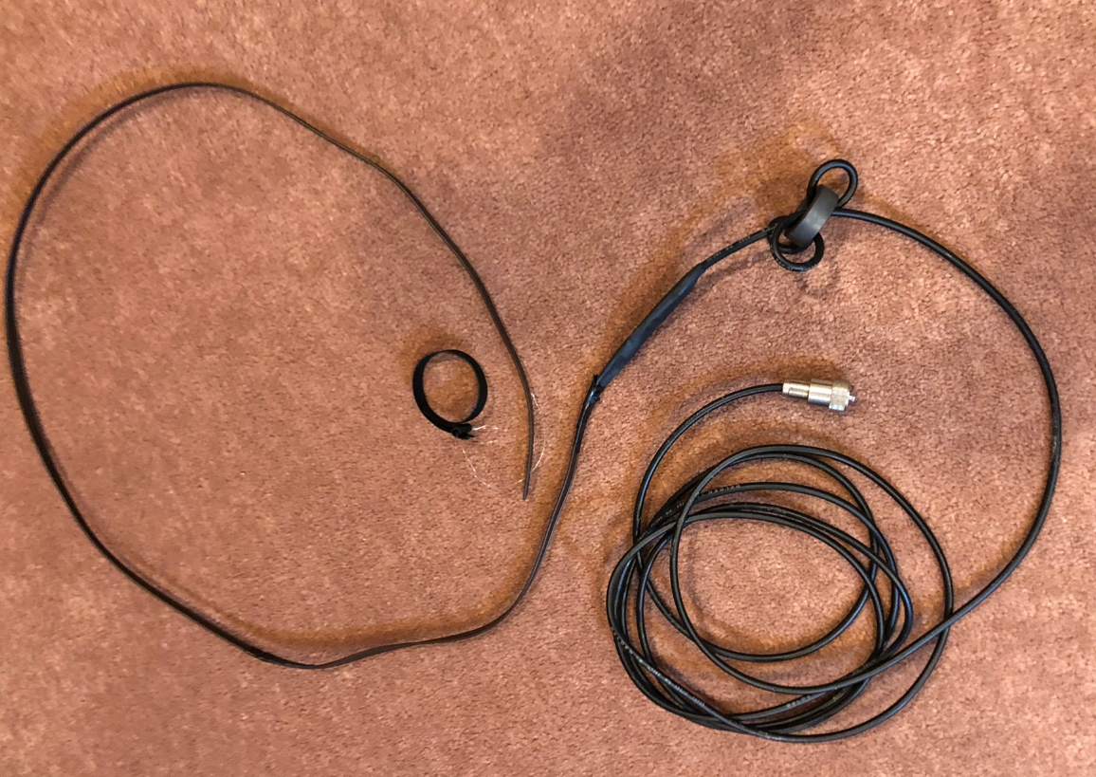

Design, Interface Circuit

First schematic from Digi-Key Scheme-It:
https://www.digikey.com/schemeit/project/fox-vox-interface-a084ee59940147349be0bb8107c3d642/

The following simple circuit would suffice but requires a strong sub-audible tone in the mp3 file in order to prevent UV-5R VOX drop-outs. The trimpot may not be needed, based in on initial testing with an iPad as the mp3 player. The transformer is probably needed to prevent undesired PTT keying if the mp3 player and radio battery eliminator share a common ground (TBD).
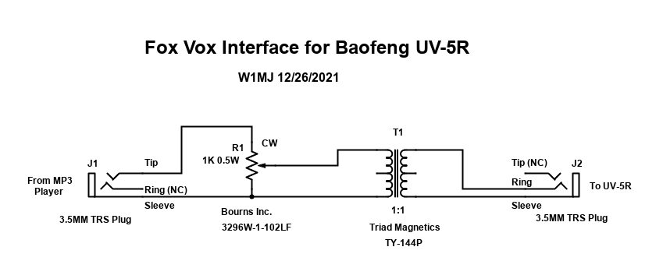

To avoid the need for the strong sub-audible tone, the circuit shown below is used. It is intended to be a better VOX. It keys the UV-5R PTT. The PTT return via the battery eliminator GND appears to suffice, but J3 is shown in the diagram just in case.

For reference, see the following:
- Appendix 1: UV-5R Interfacing Information
- Appendix 2: MP3 Player Information

Schematic, draw with Digi-Key Scheme-It:
https://www.digikey.com/schemeit/project/w1mj-fox-v21-50fef9dbfa4f4964a210be8cecc17703/

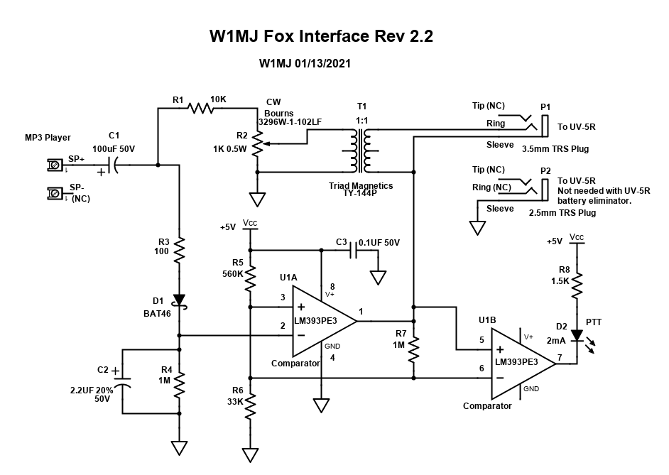

Audio peaks from the MP3 player charge capacitor C2. R3 limits the loading on the player to prevent distortion. When the voltage on C2 exceeds the reference voltage at U1-3, comparator output U1-1 pulls the radio PTT line (P1-Sleeve) to GND to key the transmitter. Hysteresis is provided by R7 to ensure clean PTT switching. When the audio pauses, C2 discharges through R4, ending transmission after approximately 2 seconds. LED D2 indicates that PTT is active.

Potentiometer R2 is used to set the audio level to the radio for proper modulation. Audio transformer T1 is needed to prevent the audio circuit from keying the PTT.

Design calculations (Excel file embedded in Word document):

Notes:
- LM393 Comparator data sheet: https://www.ti.com/lit/ds/symlink/lm193.pdf
- If an audio amp is needed for the vox, consider LM324: https://www.ti.com/lit/ds/symlink/lm324.pdf

Interface BOM, downloaded from Digi-Key schematic project then edited:

Assembly, MP3 Player & Interface Circuit

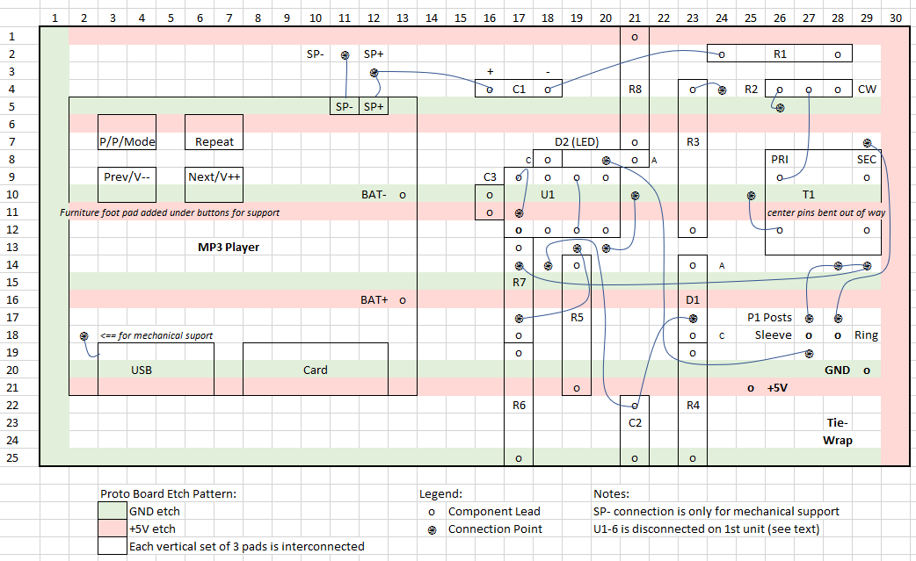

The assembly drawing is maintained in this Excel file embedded in the Word document:

Test Results

A successful test with a solderless breadboard was done on 1/9/2022.
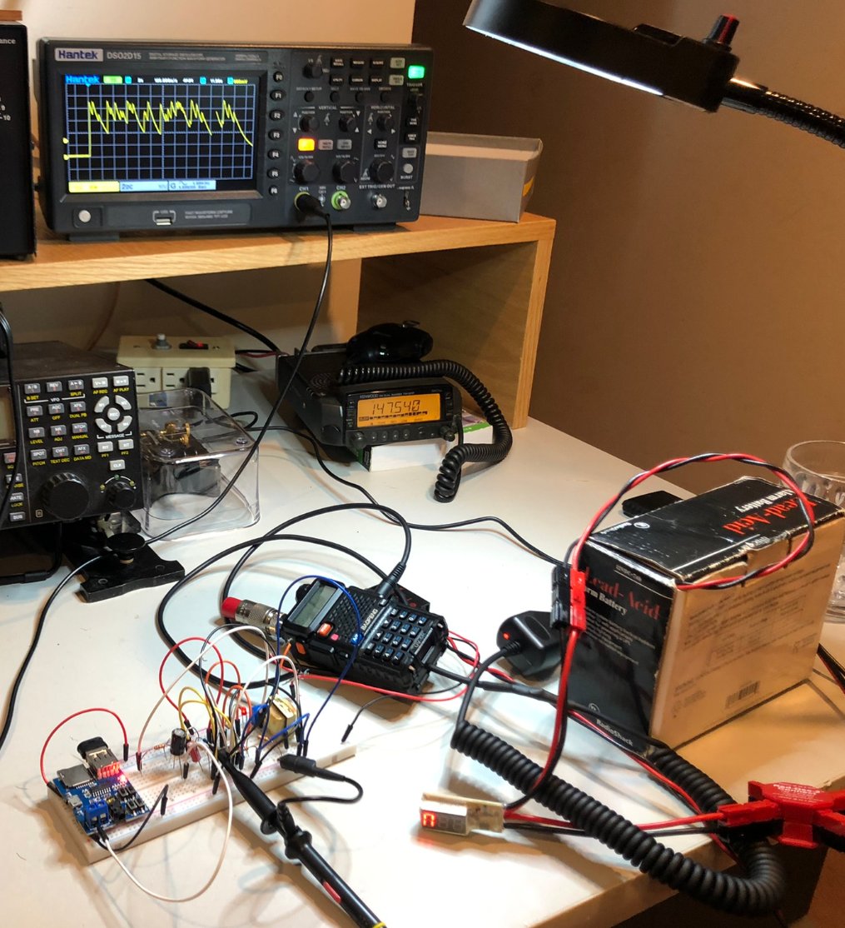

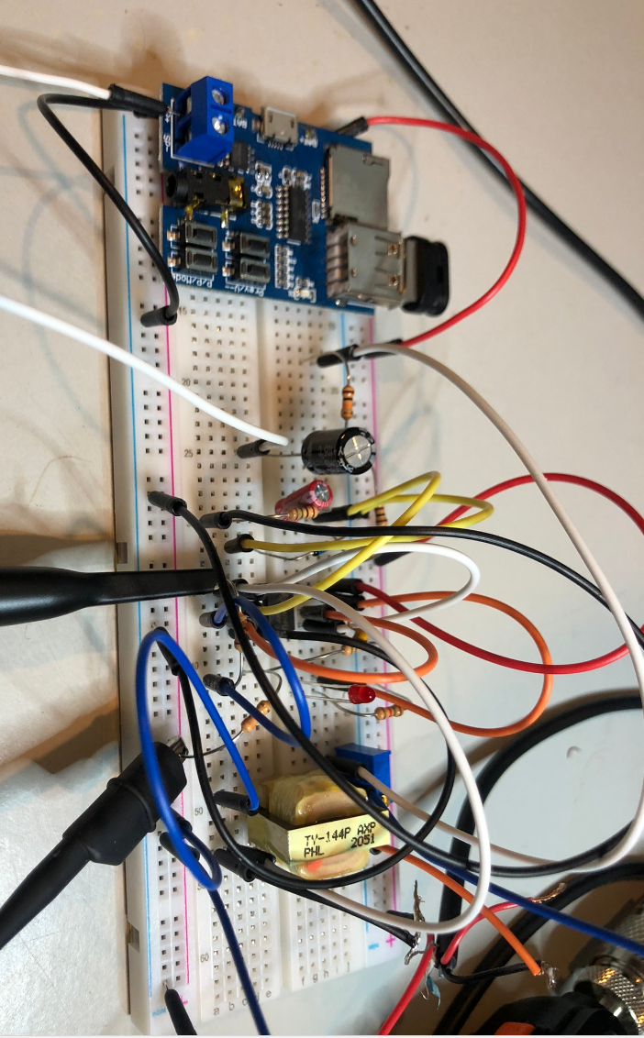
Breadboard is from REXQualis Electronics Component Fun Kit.

Bench Measurements
12V supply: 1.1A (TX=5W) / 0.6A (TX=1W), 0.0A (not transmitting)
12V supply current w/o radio: 36 mA
5V supply current: 62 mA during transmit, 60 mA when not transmitting.

The comparator threshold measured close to expected levels per Fox_Calculations.xlsx:

Vt, Rising (VOX Not Tripped) | 370 | mV
Vt, Falling (VOX Tripped) | 270 | mV

PTT voltage:
- Receive: +3.3 V
- Transmit: +80 mV

Comparator input, solderless breadboard w/o transformer:

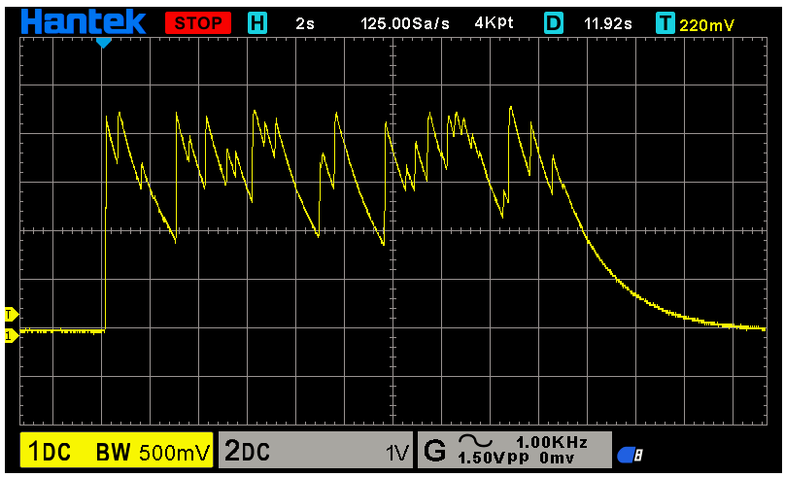

Final Assembly Tests

When the components were transferred to the prototyping board, U1B was somehow damaged. Pin 6 had about 5 kohms resistance to ground, which dragged down the comparator threshold voltage. The connection to this pin was then removed, leaving the fox functional except for the Transmit LED (D2). The LED was just a nice-to-have feature so changing U1 didn’t seem worth the trouble. In hindsight, I should have used an IC socket.

Operating Temperature: The fox ran continuously from 10 AM to 10 PM on 1/14/2022, during which time the temperature dropped down to -7˚C (20˚F). Battery voltage 13.26.

Antenna Measurements
- SWR, away from other objects: Approximately 1.5
- SWR, right next to a tree trunk: Approximately 3.0

MP3 Scripts

The audio recordings were made with Reaper DAW. Each message is preceded with a hand clap about ½ second before the message proper. This gives the VOX time to trigger and the transmitter time to start transmitting, ensuring that the start of the message is heard. The claps themselves are not heard. Only one file is stored on the MP3 player USB drive, and the player repeats the file.

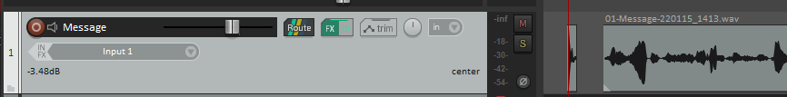
CLAP

fox_20s_60s.mp3: File for 20 second transmission once every 60 seconds. This file was only used for initial testing.

Welcome to the hidden transmitter hunt. This is the W1MJ 5-Watt fox. Please email your fox hunting report to w1mj@arrl.net. Good luck from W1MJ.

fox_12min_v1.mp3: This 12-minute file is normally used with the fox. The following messages are typically 20 seconds long and start roughly at 1 minute intervals.

- Welcome to the hidden transmitter hunt. This is the W1MJ 5-Watt fox. Please email your fox hunting report to fox@w1mj.com. Good luck from W1MJ.

- This fox uses a Baofeng UV-5R transceiver. The output power will normally be set to 5 watts but might be set to 1 watt on some hunts. W1MJ

- This fox uses an MP3 player with a homebrew interface to the transceiver. Thanks go to K1MJC and K1PJW for their contributions to the design. Photos and technical details of this fox are available online at w1mj.com/fox.

- I’m considering a fancier fox design based around a Raspberry Pi. Features under consideration include:
- limiting transmissions to daylight hours, and
- reporting battery voltage.
If you have any suggestions, please let me know. Thanks. W1MJ

- This fox has no logbook. Please email your fox hunting report, your suggestions, or your complaints to fox@w1mj.com. Thank you from W1MJ.

- Deployments of this fox are announced on two groups.io groups: Northeast Massachusetts Fox Hunters and Waltham Amateur Radio Association. W1MJ.

- CW (18 WPM): I hope you can find me DE W1MJ

- Many years ago, when most foxes were live humans, I put together an automated fox with a reel-to-reel tape recorder. I made the 2-hour tape sound like I was a live fox, and successfully fooled many hunters. I openly admit that this fox is automated. W1MJ

- According to the Transmitter Hunting article on Wikipedia, Transmitter Hunting is also known as T-hunting, fox hunting, bunny hunting, and bunny chasing. Very interesting, but then again, one cannot trust everything that one reads online. W1MJ

- Fox hunting equipment can be very sophisticated but does not have to be. I hunt with only a walkie-talkie, a whip antenna, and a 30 dB attenuator that I can put inline with the antenna. I use the “body fade” method and pay attention to signal strength. W1MJ

- I usually fox hunt along with my dog Noah. Once, Noah and I were just out for a hike in the Middlesex Fells Reservation, and Noah suddenly broke into a run. I looked and saw that he was doing a more traditional fox hunt. That fox got away. W1MJ

- CW (18 WPM): Good luck finding the fox DE W1MJ

fox_18min_v1.mp3: This 12-minute file is normally used with the fox. The following messages are typically 20 seconds long and start roughly at 1 minute intervals.

- Welcome to the hidden transmitter hunt. This is the W1MJ 5-Watt fox. Please email your fox hunting report to fox@w1mj.com. Good luck from W1MJ.

- This fox uses a Baofeng UV-5R transceiver and a twin-lead J-pole antenna. The output power will normally be set to 5 watts. W1MJ

- This fox uses an MP3 player with a homebrew interface to the transceiver. Thanks go to K1MJC, K1PJW, and N1JAF for their contributions to the design. Technical details of this fox are available at w1mj.com/fox. W1MJ

- I’m considering building a fancier fox. Features under consideration include:
- limiting transmissions to daylight hours, and
- reporting battery voltage.
- If you have any suggestions for features, please let me know. Thanks. This is W1MJ.

- I first thought that a Raspberry Pi would be good for controlling a fancier fox, but that might be overkill. An Arduino might suffice, though at the QSO Today Virtual Ham Expo, I heard about a Raspberry Pi Pico that might be a candidate – it comes with MicroPython.

- If you have any suggestions for the design of a fancier fox, especially the choice of microcomputer, I’d love to hear them. Please email me at fox@w1mj.com. Thanks. W1MJ

- Deployments of this fox are announced on the Northeast Massachusetts Fox Hunters group on groups.io. Sign up at groups.io/g/NEMassFoxHunters. W1MJ.

- This fox has no logbook. Please email your fox hunting report, your suggestions, or your complaints to fox@w1mj.com. Thank you from W1MJ.

- CW (18 WPM): I hope you can find me DE W1MJ

- Many years ago, when most foxes were live humans, I put together an automated fox with a reel-to-reel tape recorder. I made the 2-hour tape sound like I was a live fox, and successfully fooled many hunters. I openly admit that this fox is automated. W1MJ

- My old fox was once used at a ham radio convention. I was monitoring it on a borrowed handheld, as mine was in the fox box. Some guy came up to me and asked, “Are you the fox”? That was not an easy question to answer. W1MJ

- Since I was hearing that fox on the borrowed handheld, and I was not speaking at that moment, I decided that the answer was “no”. That hunter complained to the convention committee that I lied, and that he should have won the prize. W1MJ

- Fox hunting equipment can be very sophisticated but does not have to be. I start with only a walkie-talkie and its whip antenna. When I get close, I add a 30 dB attenuator and then switch to a sawed-off antenna – about 1 inch long.

- I hunt using the “body fade” method, which I used to call “the belly button reflector method” but due to reflections from hills and such, I don’t find it to be accurate until I am very close to the fox. Mostly I pay attention to signal strength. W1MJ.

- When I’m really close to the fox, I use no antenna. My Yaesu VX5R is well shielded and lets me use the body fade method even close to a 5-watt fox. Some radios are less well shielded and require other hunting methods close in. W1MJ

- I usually fox hunt along with my dog Noah. Once, Noah and I were just out for a hike in the Middlesex Fells Reservation, and Noah suddenly broke into a run. I looked and saw that he was doing a more traditional fox hunt. That fox got away. W1MJ

- Lots of fox hunting information is available online. Jeff AC1JR and I did a presentation at a Waltham ARA meeting; the slides are available on walthamara.org/blog. W1MJ

- CW (18 WPM): Good luck finding the fox DE W1MJ

Appendix 1: UV-5R Interfacing Information

From http://www.miklor.com/COM/UV_Technical.php

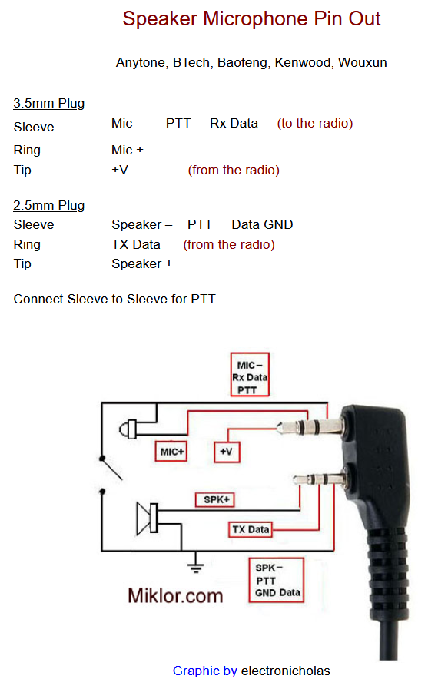

From https://k0rx.com/blog/2017/11/baofeng.html

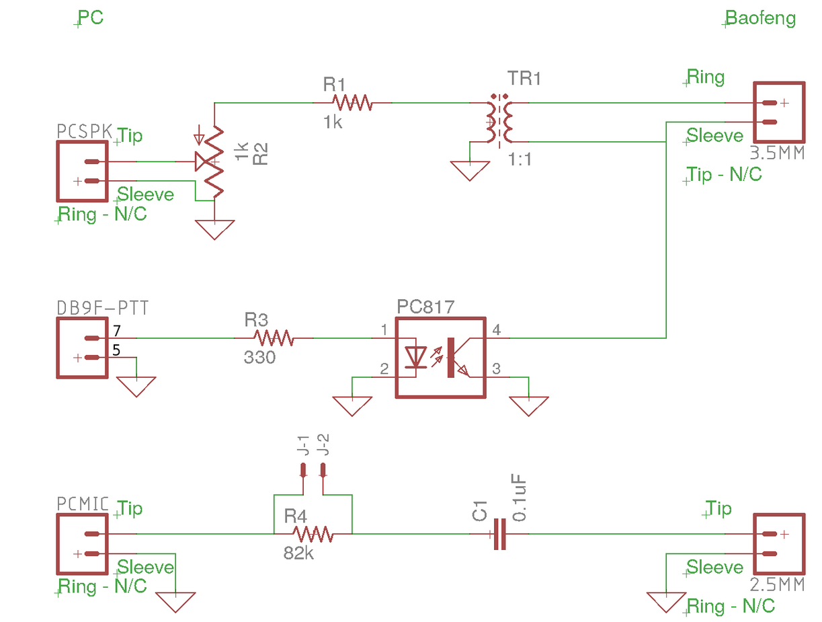

Measurements:
- On UV-5R:
  - All 3 connections to the 3.5 mm jack measure +3.3VDC against sleeve of 2.5 mm jack.
  - All connections to the 3.5 mm jack measure 0 VDC against each other.
  - The sleeve of the 2.5 mm jack is connected to Battery Eliminator (-) contact.
  - Keying radio with DMM from 3.5 mm jack sleeve to 2.5 jack sleeve, current measured about -7 mA (unstable, but always negative {?}). See next item…
  - Keying radio with DMM from 3.5 mm jack sleeve to battery eliminator – (cigarette lighter plug), current measurement depended upon setting of Radio Shack DMM; it was either +0.5 mA or -1.5 mA.
- With direct connection of iPad Ring/Sleeve to radio Ring/Sleeve:
  - The audio level seems reasonable (without attenuation).
  - VOX dropped out unexpectedly a few times with voice recording.
  - VOX stays on with a strong sub-audible tone added to the voice recording.

Appendix 2: MP3 Player Information

Description from Amazon
https://smile.amazon.com/gp/product/B07N1YMDK3

Use this DIY MP3 player/audio decoder module to build your own MP3 player, Boom Box or portable audio player. Connect directly to headphones, or pair the stereo output of this player with an audio amplifier board to power your speakers.
Description:
- Plays MP3 audio files on a TF (MicroSD) card (the memory card used in cell phones), or a USB drive in U disk playback mode.
- Superior sound quality, 3.5mm headphone jack to connect headphones or to an external stereo amplifier. Onboard 2W mono amplifier to directly connect a speaker (single channel only for monitoring, not appropriate for stereo playback).
- Screw-type terminals to connect an external speaker (no soldering).
- Can be powered with standard 5V USB power (a USB power supply or power bank) through the Micro USB power connector. Can also be powered by a 3.7V to 5.5V battery or external power supply (connected to "Bat+" and "Bat-" terminals on either side of Micro USB power input connector.
- Module designed to facilitate modification.
Product Overview:
- Supports MP3 format, automatically plays when TF card or USB drive is inserted, onboard red LED indicates power and status (solid red when power is on but not playing, flashing red when playing).
- U disk support (tested 32GB), TF card (tested 16GB) Play mode. TF card is the power-on default mode, if TF card is not inserted will play the USB drive. If both devices are installed, you can manually set the playback mode, (see Button Operating Instructions below).
- The buttons select Previous/Next tracks, Volume + -, Pause / Play, Device Mode Switching (TF Card or USB Drive input), Repeat.
- Input power range: 3.7V to 5.5V
- Size: 45mm * 36mm (1.75" x 1.4")
- Double layer board design, large copper traces and planes, stable and reliable.
Product information
Package Dimensions | 6.5 x 4 x 1 inches
Item Weight | 1.58 ounces
Manufacturer | Unbranded/Generic
ASIN | B07N1YMDK3
Customer Reviews | 3.9 out of 5 stars 4 ratings  3.9 out of 5 stars
Best Sellers Rank | #45,416 in Electronics (See Top 100 in Electronics)  #291 in MP3 & MP4 Players
Is Discontinued By Manufacturer | No
Date First Available | January 23, 2019

MP3 Player Measurements & Observations

- Neither Speaker terminal is connected to BAT- (GND).
- The sleeve of the 3.5 mm jack is connected to BAT- (GND).
- When playing an mp3, there is a blinking red LED.
- Output:
  - Headphone jack: Approximately 200 mV peak AC at maximum volume, 0 VDC offset.
  - Speaker+ terminal: +2.5 VDC offset. Approximately 2V peak at maximum volume:
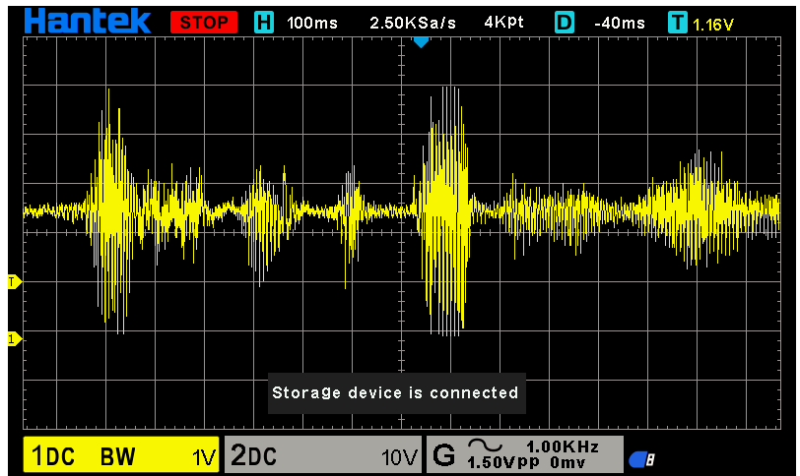
    - No output if plug inserted in headphone jack.

Ideas for Future Foxes

The audio transformer is probably not needed. From Jeff AC1JR:

I followed the miklor.com pinout:

http://w1mj.com/fox/index_files/image029.png

The wires on the two TRS plugs:

2.5mm S: connected to circuit ground
3.5mm R: connected to the coupling cap
3.5mm S: connected to the button, other side of the button is connected to
to circuit ground

All others are unused.

